Dip Chowdhury  
52/4, West Rajabazar, Tejgaon, Dhaka • +88 016 85117737 • [dipbd1@gmail.com](mailto:dipbd1@gmail.com)

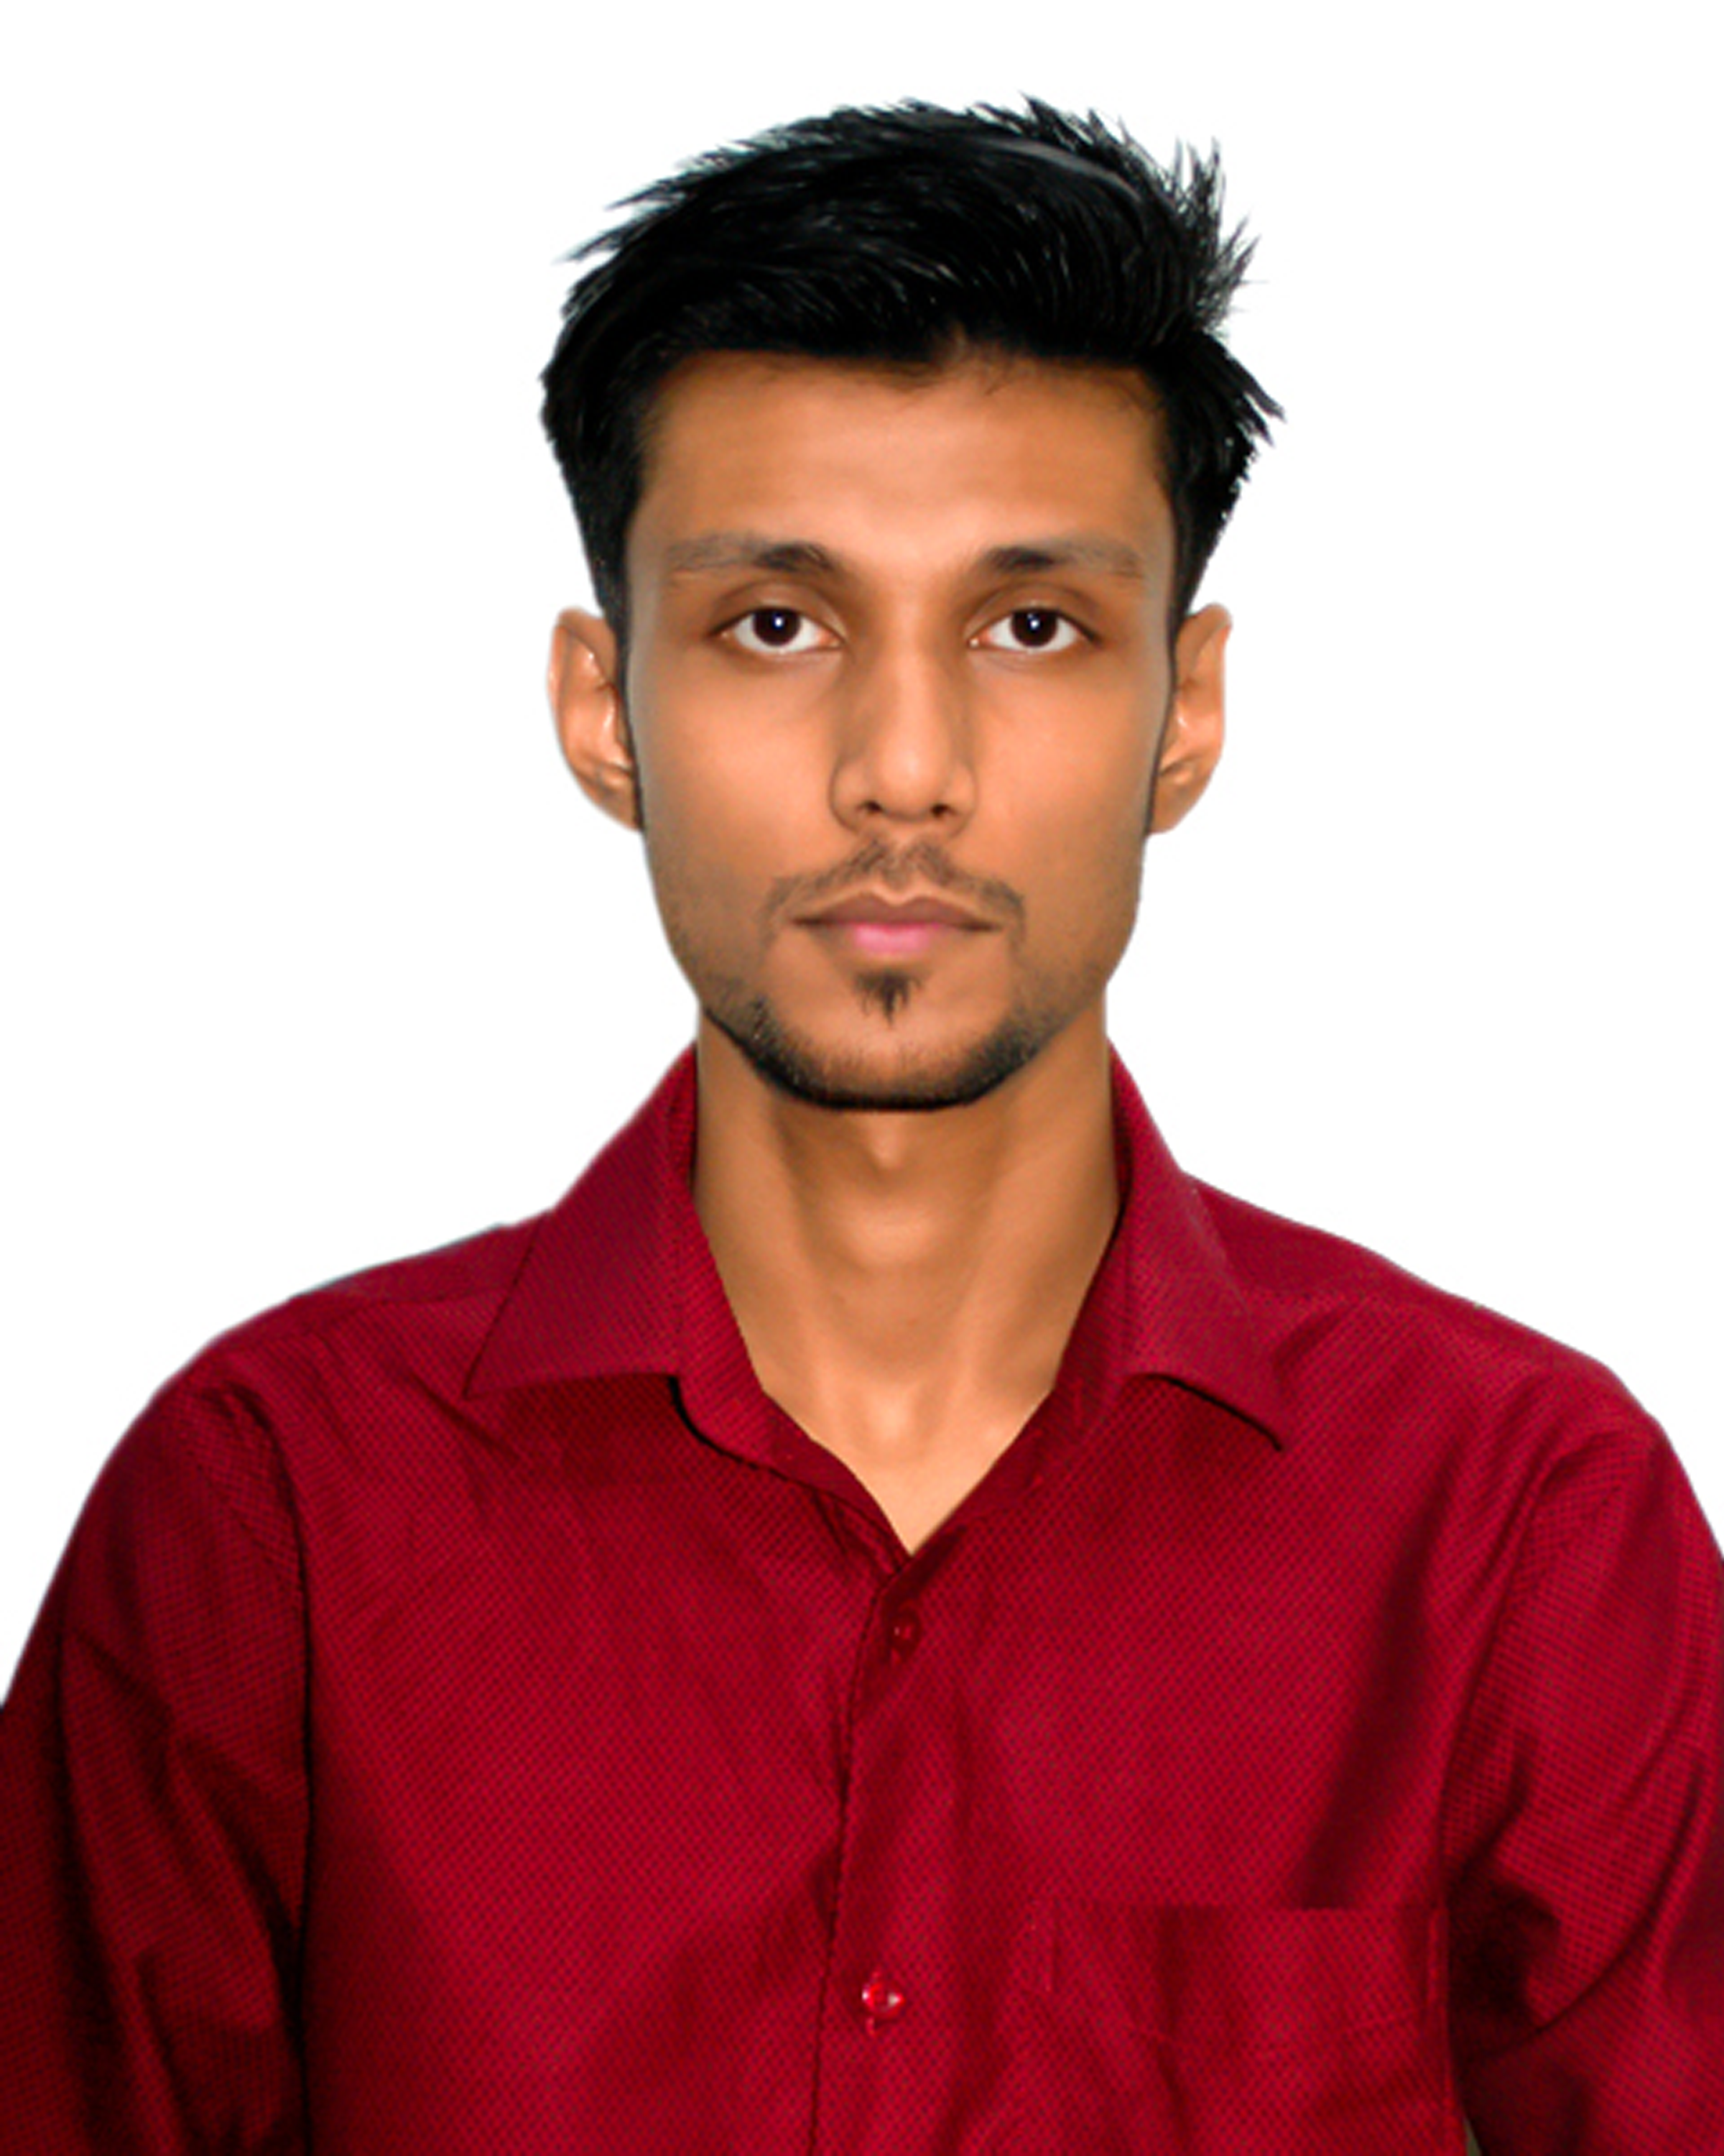

.1

Software Engineer  
- Software & Technology Industries -

Highlights of Qualifications:

* Experience in a broad range of technical skills including Java Application development, Android Application Development, Real-Time and Embedded System development. C/C++ Programming, DB Design, Shell Scripting, SQL, Networking Architectures, OS Architectures, System Architectures, Software Development Life Cycles.
* Ability to work independently, under pressure, to multi task, attention to detail, and work to deadline.
* Bachelor of Engineering in Software Engineering

Android Projects

* ICT Act BD (https://play.google.com/store/app s/details?id=four.ingenium.cyberactbd)
* Robikotha (https://play.google.com/store/app s/details?id=robikotha.ingenium.fo ur.robikotha)
* Kids Learn Ground (https://play.google.com/store/app s/details?id=four.ingeniumbd.kidsle arnground)

Links:

* **Github**: <https://github.com/dipbd1>
* **CodeForces**: <https://codeforces.com/profile/dipbd1>
* **LinkedIn**: <https://www.linkedin.com/in/dip-chowdhury-04a510143/>

Current Status:

Working at Daffodil Software Limited as intern. Here I am working with many technologies focusing python as programming language. Completed learning Django Frame work, Currently Learning “Odoo” and machine learning for future projects.

Education:

**B.Sc. in Software Engineering** from **Daffodil International University** with CGPA 3.12 (2014 – 2018)

* Final Defense with Project - Fall 2018
* Designed A System architecture to provide safety for Water Vehicles
* Implemented system on a Demo Vehicle with equipment.
* Web Project – Fall 2017
* Developed an Android App that can track movement of a user and will upload this data to a Database.
* Developed interface and developed code.
* Desktop Application - Fall 2016
* Created a Custom Database with C programing that take input as a string and save as a string.
* DIU Project Fair - Fall 2015
* Developed Blood Group Database with core C.

**M.Sc. in CSE** from **Jahangirnagar University** (2019 – Now)

**Competed** in **ACM-ICPC** contest in 2016

Technical Skills:

**Languages**: C, C++, Java, .Net, Python(Currently Working), Scratch  
**Web**: JavaScript, CSS, and HTML, TCP/IP Sockets, Network Diagnostics  
**Operating:** System: Experienced is UNIX like environment, All Windows Operating System Versions  
**Software** **Package**: MS Office, Adobe Creative Suite, FL Studio, nMap, Ludwig, GitHub

**Current Status**

Daffodil Software LTD

**Junior Software Engineer**

* Working with **Odoo**
* Building custom module
* Implementing different technology
* **AI** Related Study

Work Experience:

Ingenium BD,1, 2 Nurjahan Rd, Dhaka 1207  
**Junior Android Developer**

* Working with Senior Developers.
* Designing App interface, Architecture and implementing with Java.

Josudo.com(Singapore)  
**Creative Content Creator and Analyst**

* Creating Video for a broad range of viewer
* Planning and Preparing video content for Users
* For selected game, Creating Analytical video for each update and releases

Samsung Global, 111 Sonargaon Road, Dhaka 1205

**Graphics Designer**

* Pre and Post Editing Image for Newspaper
* Creating Advertisement Assets